BURORA HEALTH FACILITY
S/N | Name of Facility | Picture
1 | Burora Health Facility | 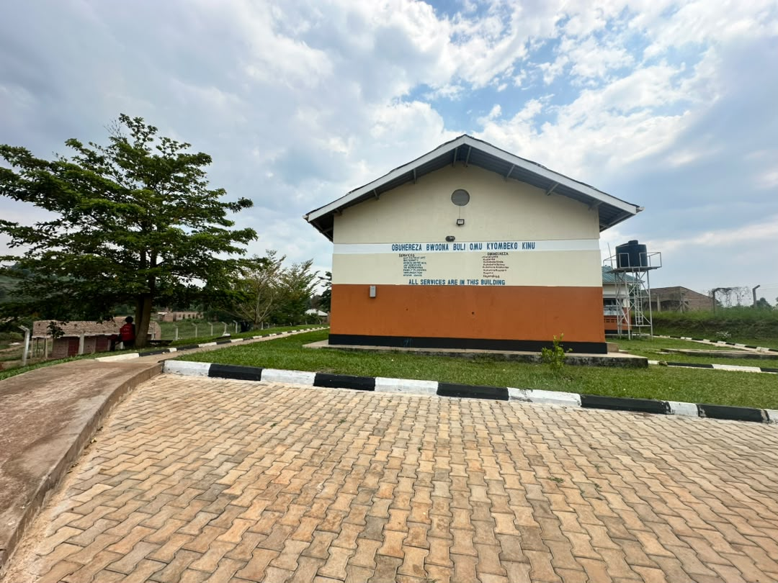
2 | Burora Health Facility | 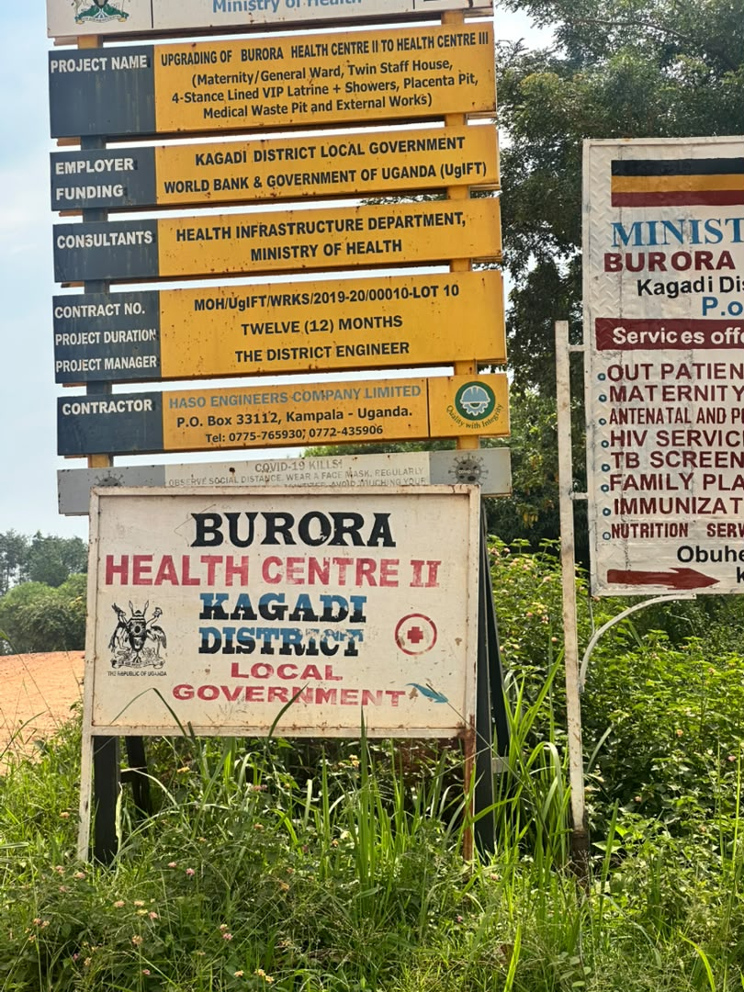
3 | Burora Health Facility | 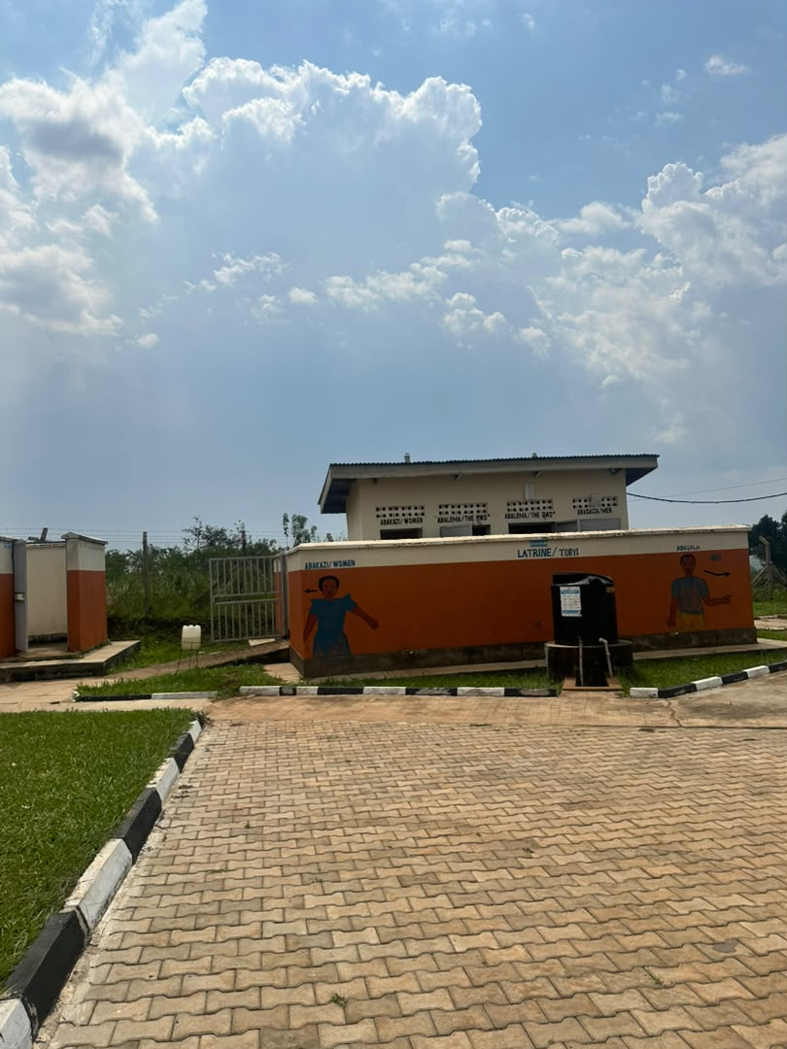
4 | Burora Health Facility | 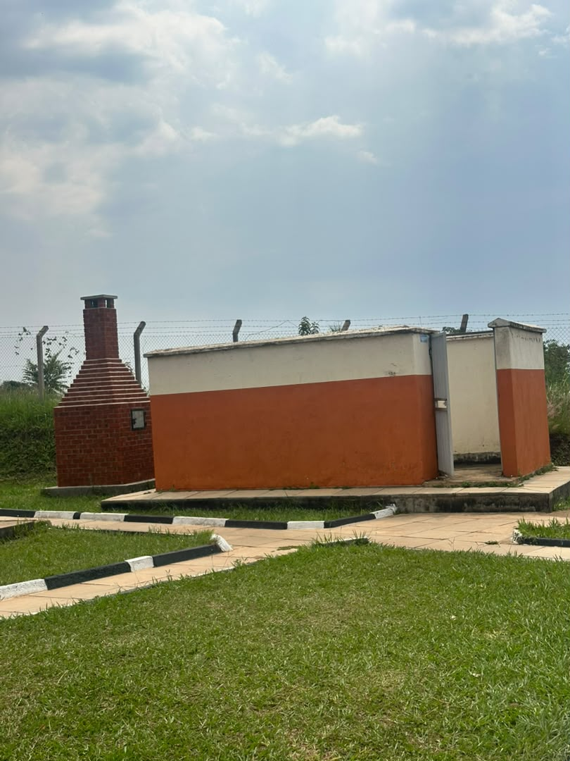
5 | Burora Health Facility | 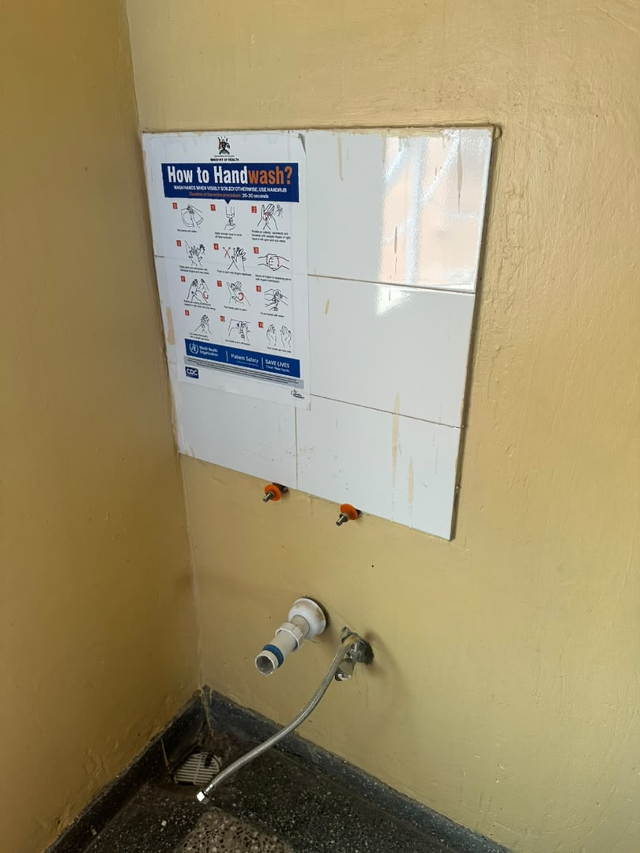
6 | Burora Health Facility | 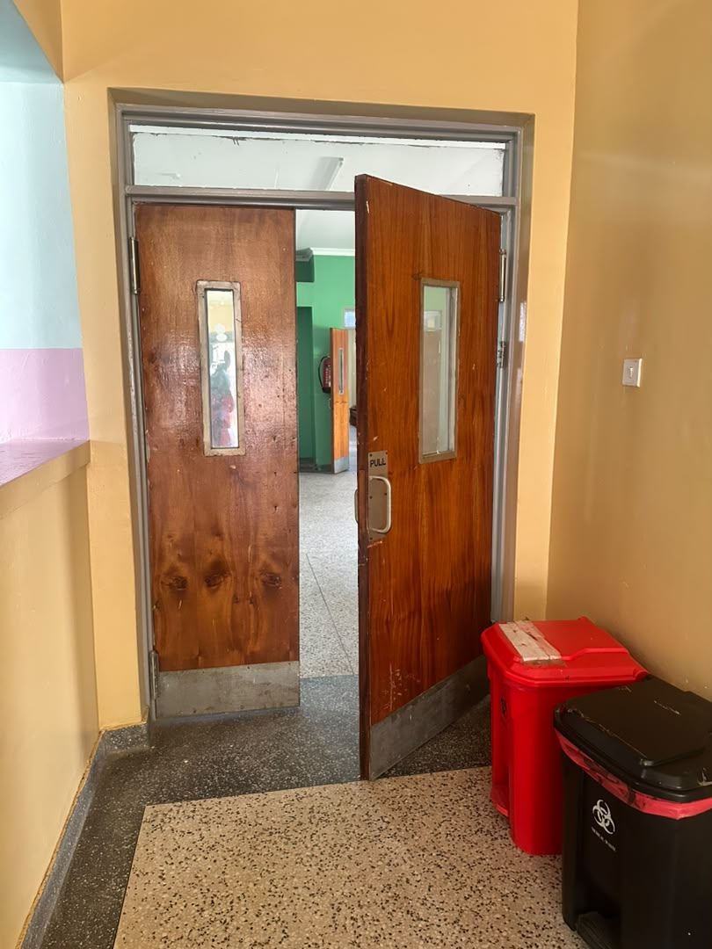
7 | Burora Health Facility | 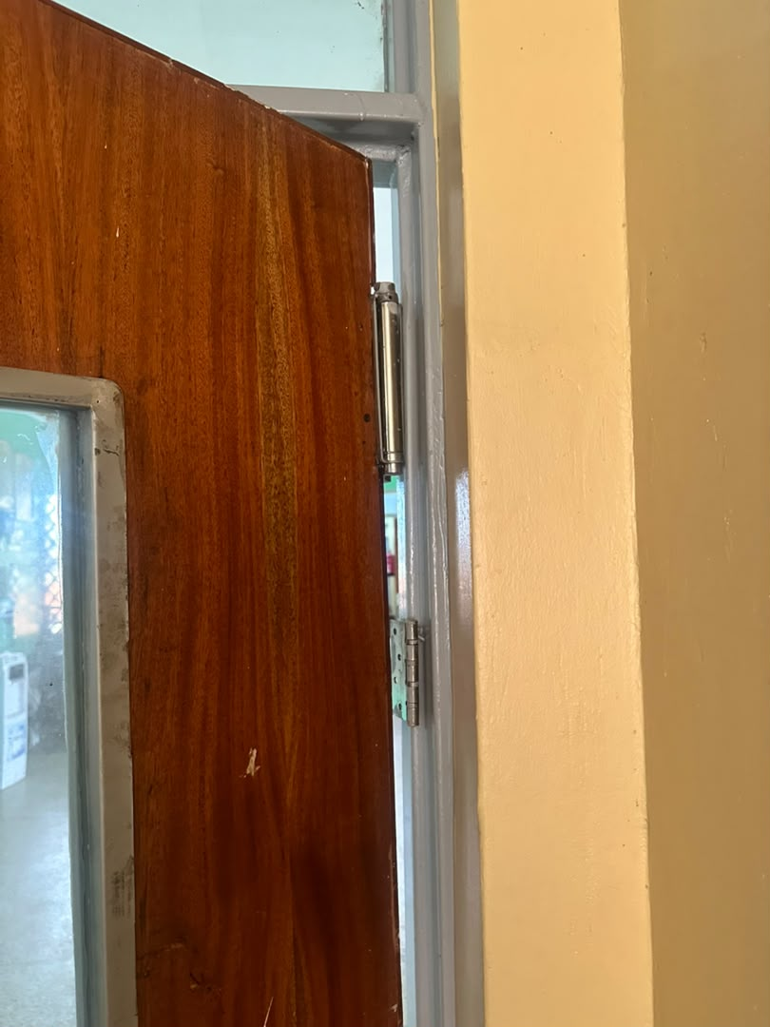
8 | Burora Health Facility | 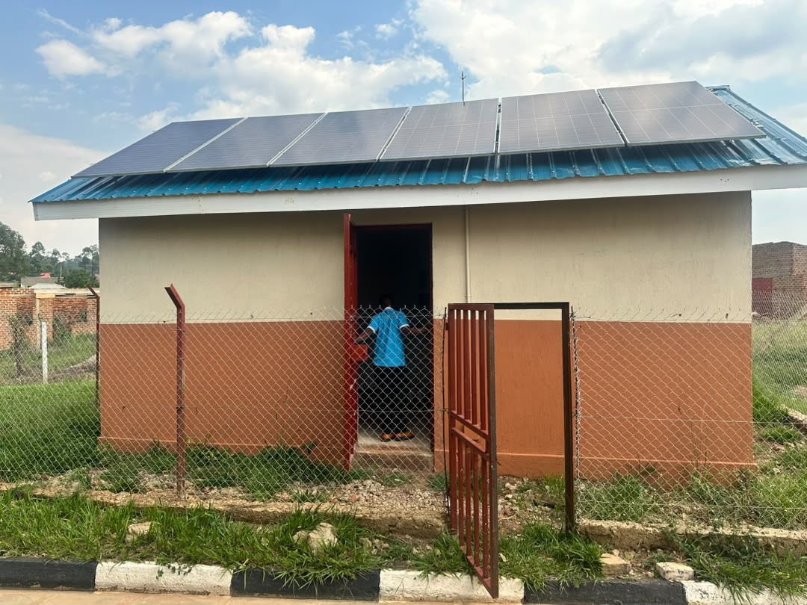
9 | Burora Health Facility | 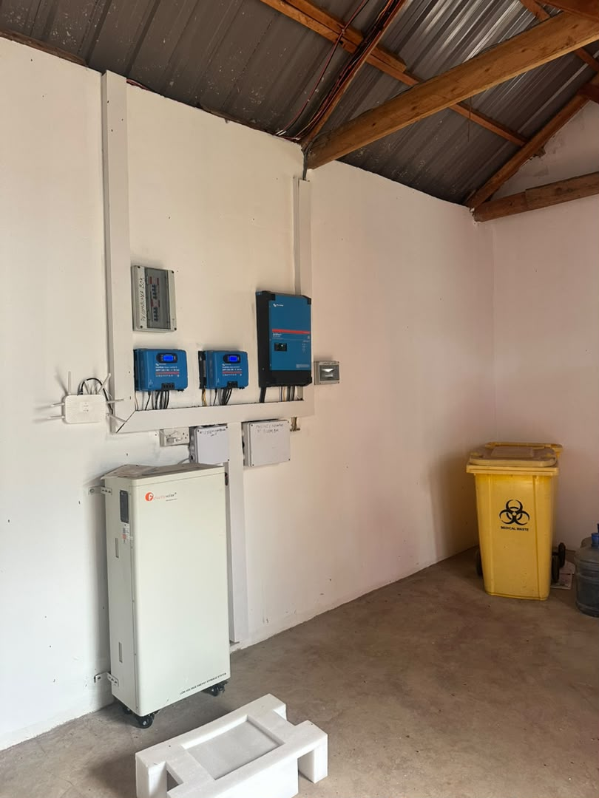
10 | Burora Health Facility | 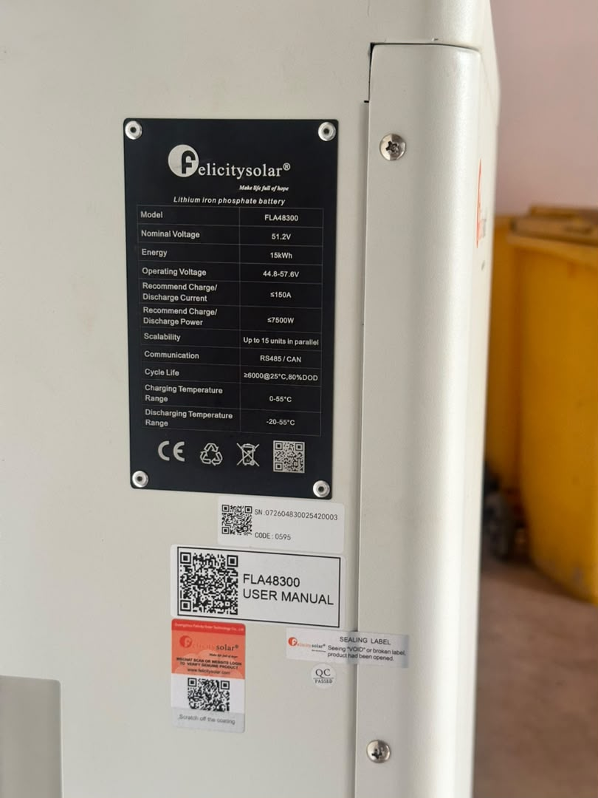
11 | Burora Health Facility | 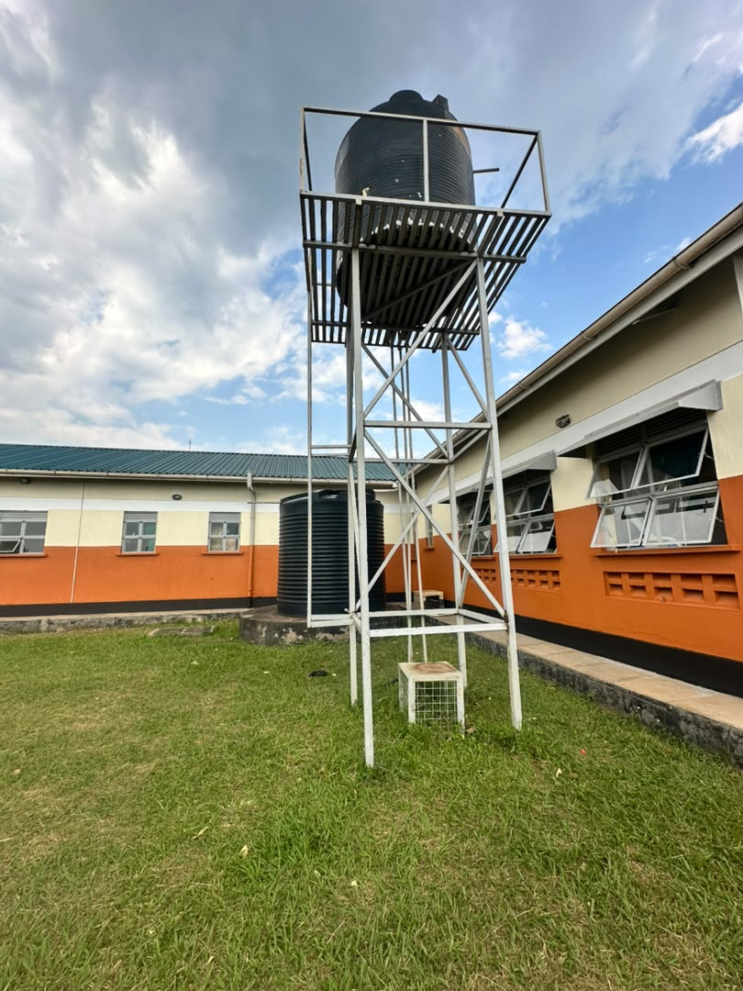
12 | Burora Health Facility | 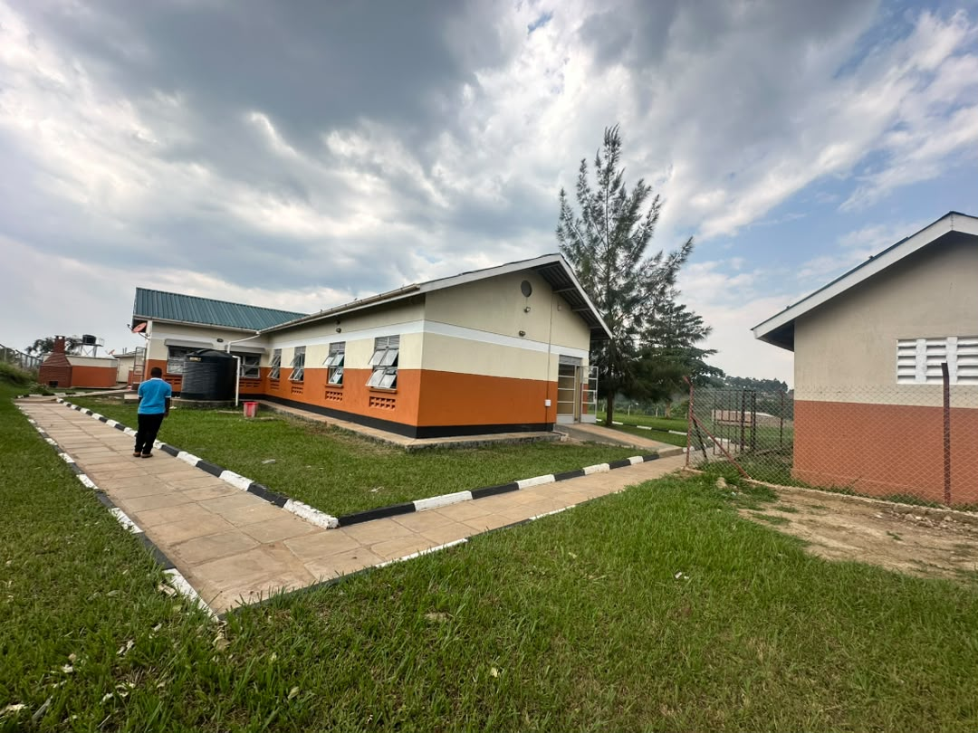
13 | Burora Health Facility | 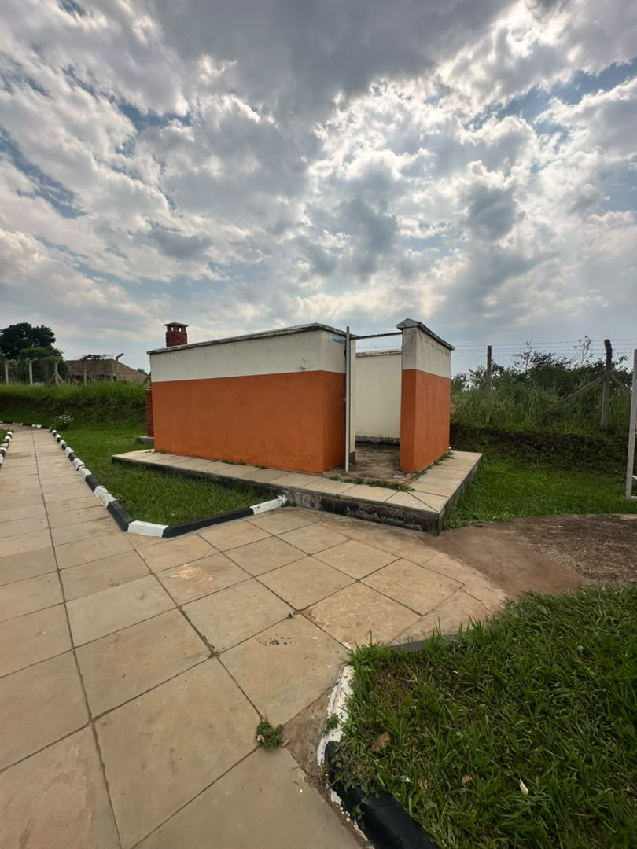
14 | Burora Health Facility | 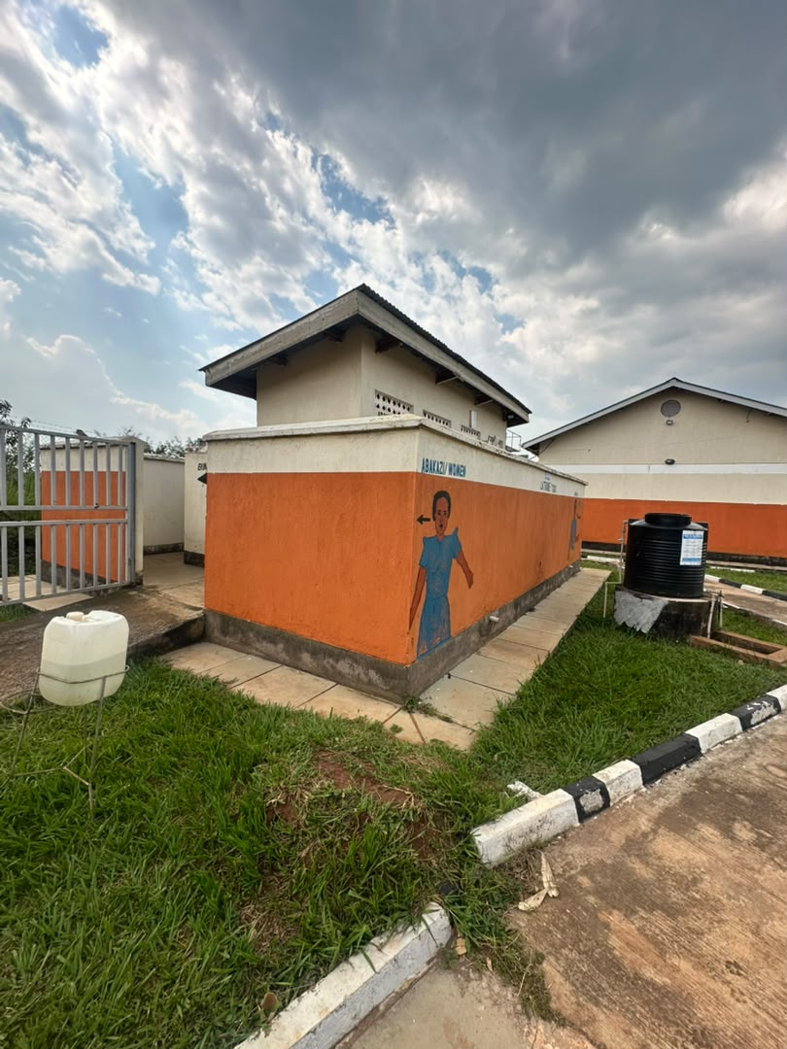
15 | Burora Health Facility | 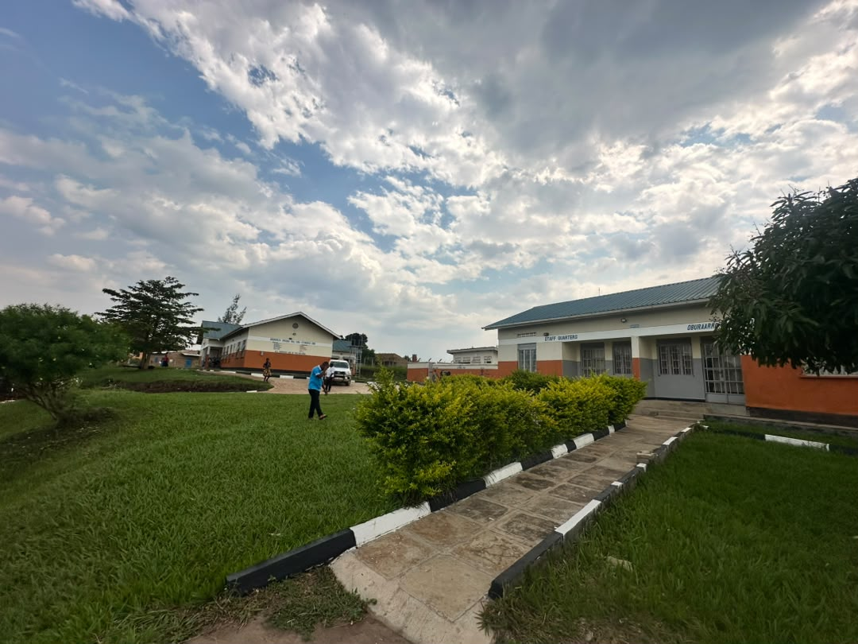
16 | Burora Health Facility | 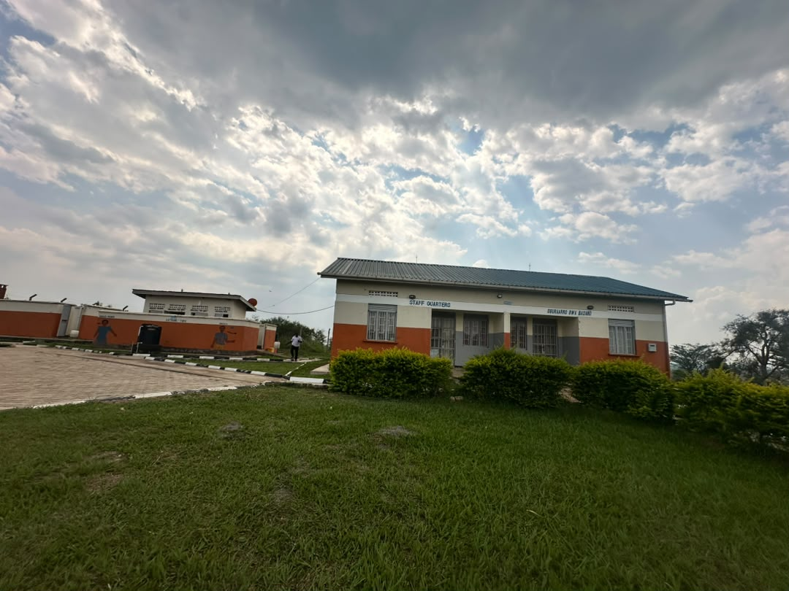
17 | Burora Health Facility | 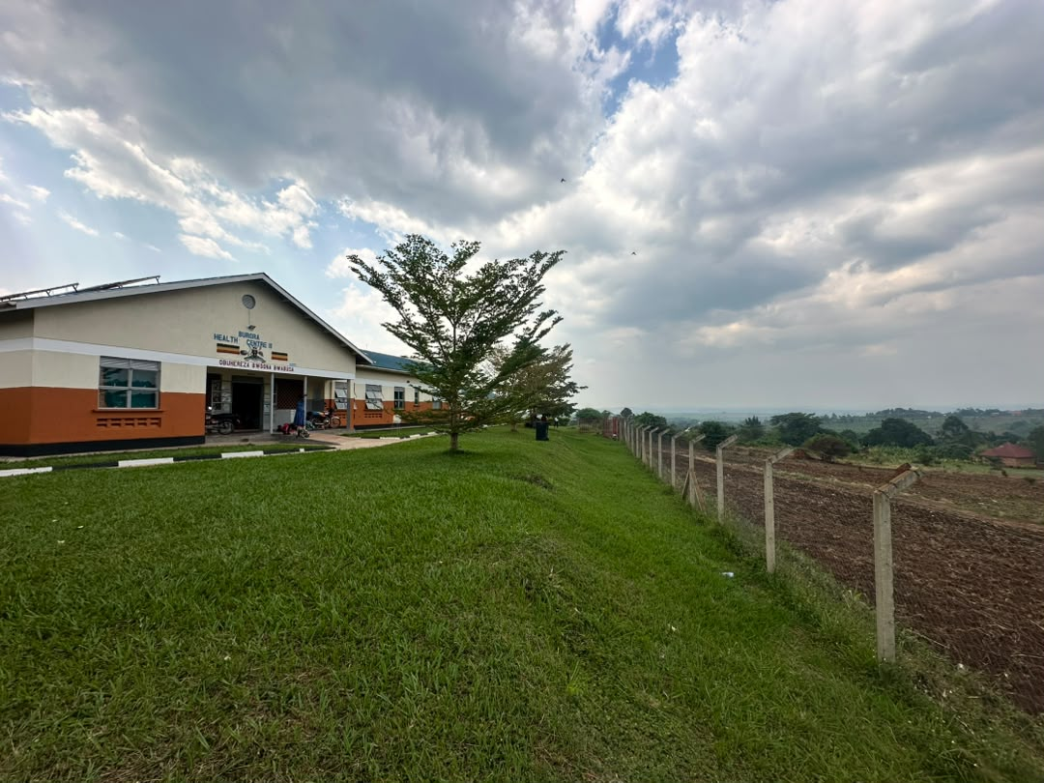
18 | Burora Health Facility | 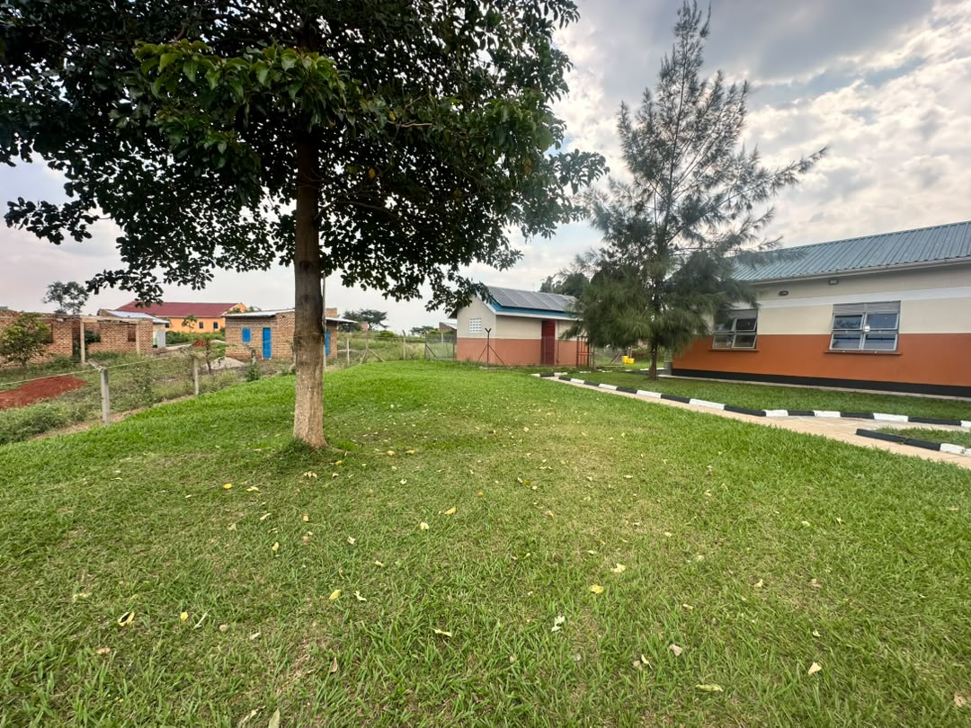
19 | Burora Health Facility | 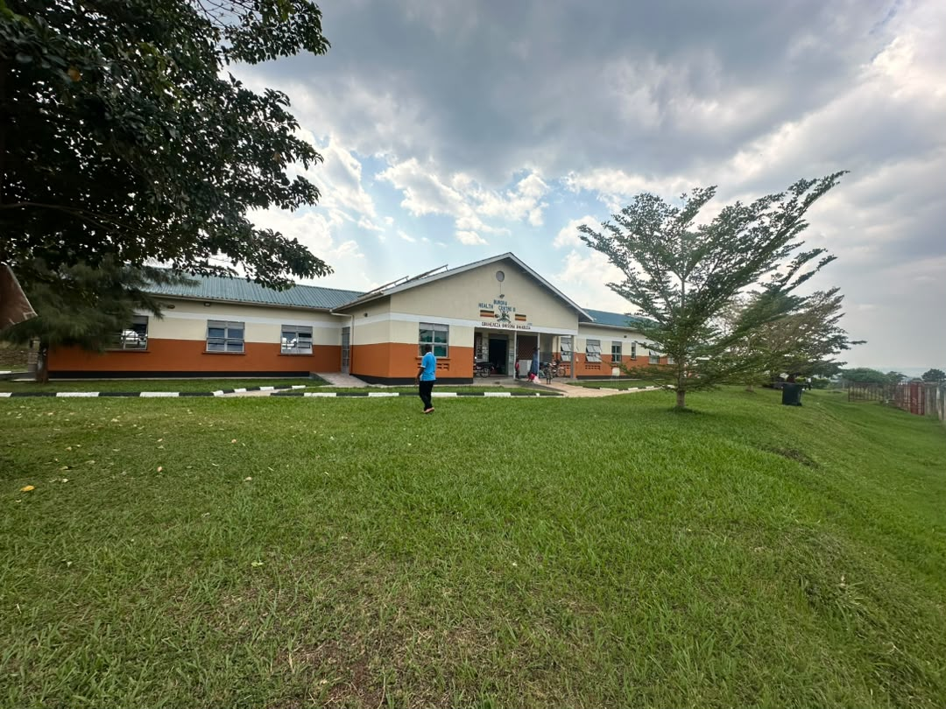
20 | Burora Health Facility | 